Communication
Kilmessan Mixed NS prides itself in having ‘open communication’ in the school. If you have any queries, problems or concerns regarding your child, please contact your child’s teacher by phoning or emailing the School Secretary to arrange to meet with them. When making the appointment please indicate the nature of your concern e.g. class work, behaviour related, personal etc. and the meeting will be arranged at a time that suits both parent/guardian and teacher.
In addition, if there is a change in home circumstances that a “Handle with Care” email will not cover, (e.g. illness, separation or anything you feel may affect your child in school) it is important to inform the school. We can assure you of the utmost confidence.
Complaints
Kilmessan Mixed NS adheres to the nationally agreed complaints procedures. The parental complaints procedure agreed by the INTO and the management bodies of primary schools is designed to provide an open and clearly defined process to facilitate parents/legal guardians in raising concerns about their own child(ren) in an agreed, fair and transparent manner, with a view to seeking an early resolution of the issue.
Issues should be raised in a timely manner. It is in the best interests of the child that issues are raised to achieve resolution at the earliest possible stage with the teacher.
The purpose of the revised procedure is for parents and legal guardians to engage constructively with schools where a concern arises and to have it addressed at local level in an efficient manner, in the best interests of all parties.
The nationally agreed procedures can be viewed here.
This policy was ratified by the Board of Management in January 2024.

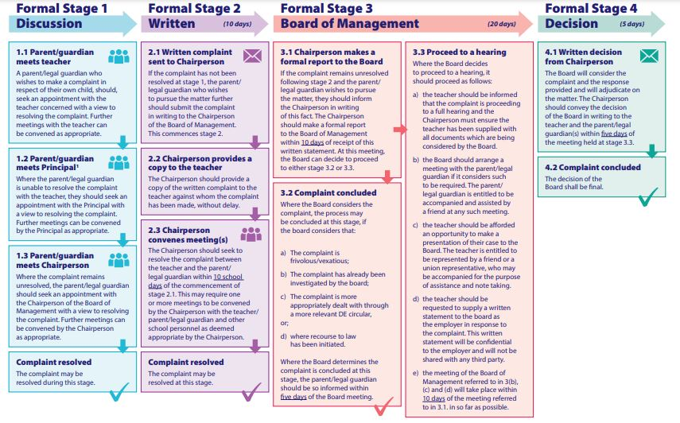
Appendix
- Where the term written correspondence is used, this refers specifically to a letter or email correspondence from a parent/legal guardian(s)
- Only complaints about a teacher which are written and signed by a parent/legal guardian, and which relate to their own child, will be investigated
- Days in this procedure refer specifically to school days. A school day is a day on which the school is in operation. Holiday periods and school closures are not counted as school days for the purpose of this procedure
- Group/collective complaints are not provided for and each parent/legal guardian raising a concern will be dealt with separately through this process
- The procedure is a domestic forum and accordingly, neither management nor the INTO intends that there would be legal representation at any stage.

